Model practical
Question1:
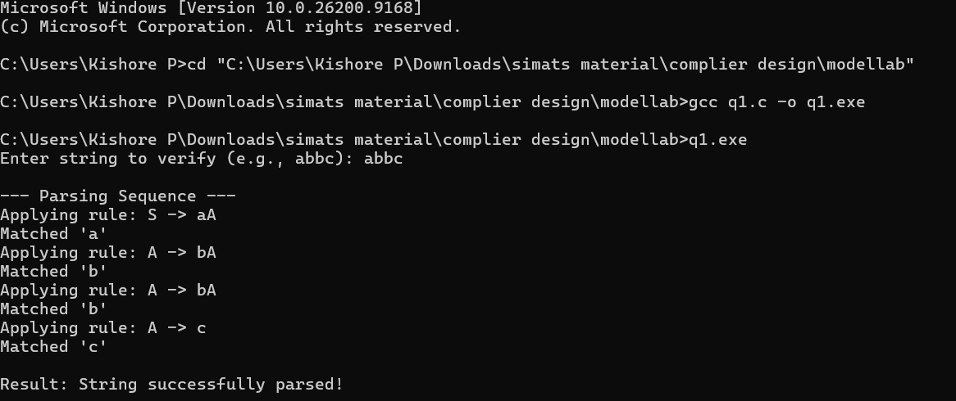
Question2:
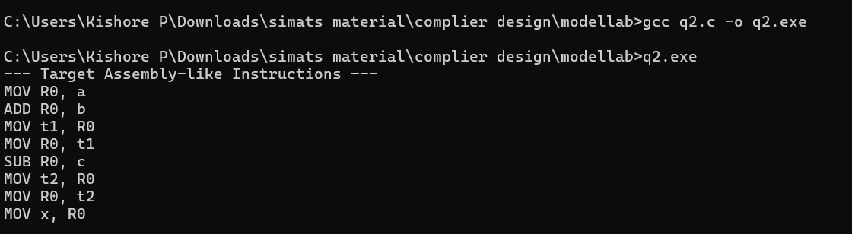
Question3:
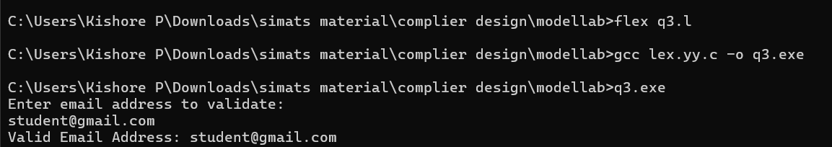
Question4:
